|  |
| --- |
|  |
| D1.1 – Project Management, Quality Assessment and Financial Plan |
| Decorative  BINGO  Brain Imagined-Speech Communication |
|  |

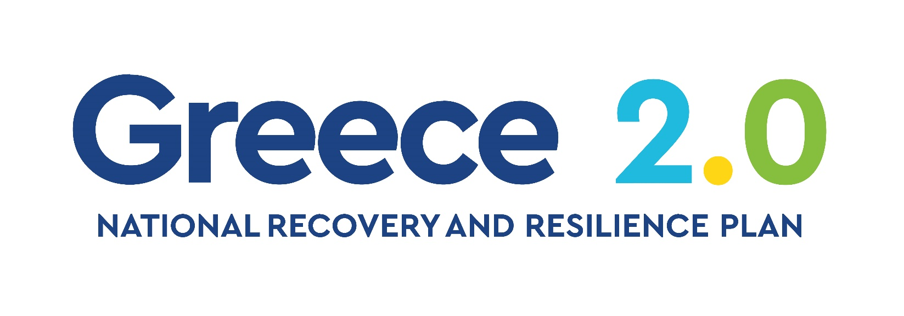

The research project is implemented in the framework of H.F.R.I call “Basic research Financing (Horizontal support of all Sciences)” under the National Recovery and Resilience Plan “Greece 2.0” funded by the European Union – NextGenerationEU (H.F.R.I. Project Number: 15986).

|  |  |
| --- | --- |
| **Dissemination level:** | Confidential (CO) |
| **Contractual date of delivery:** | Month 3, 28/02/2024 |
| **Actual date of delivery:** | Month 3, 28/02/2024 |
| **Work Package:** | WP1 - Project Management |
| **Task:** | T1.1 - Administrative and financial management |
| **Type:** | Report |
| **Approval Status:** | final |
| **Version:** | 1 |
| **Number of pages:** | 15 |
| **Filename:** | BINGO_deliverable_template.docx |
| **Abstract:** This deliverable incorporates all procedures related to the technical, financial, and administrative management of the project. It also addresses the communication and collaboration channels among the research team members. In more detail, this document describes the methodology adopted in BINGO for communication and reporting, as well as the employed quality assurance procedure (i.e. approval and quality metrics for deliverables). Additionally, it describes the operational and management procedures to be used in this project. It is based on and is consistent with the Technical Document. | |
| The information in this document reflects only the author’s views and the European Community is not liable for any use that may be made of the information contained therein. The information in this document is provided as is and no guarantee or warranty is given that the information is fit for any particular purpose.  The user thereof uses the information at its sole risk and liability. | |

### **History**

|  |  |  |  |
| --- | --- | --- | --- |
| **Version** | **Date** | **Reason** | **Revised by** |
|  |  |  |  |
|  |  |  |  |
|  |  |  |  |
|  |  |  |  |
|  |  |  |  |
|  |  |  |  |
|  |  |  |  |

### **Author list**

|  |  |  |
| --- | --- | --- |
| **Organization** | **Name** | **Contact Information** |
|  |  |  |
|  |  |  |
|  |  |  |
|  |  |  |
|  |  |  |
|  |  |  |

### **Abbreviations and Acronyms**

|  |  |
| --- | --- |
| DR | Deliverable Responsible |
| PI | Principal Investigator |
| ToC | Table of Contents |
| WP | Work Package |

Contents

History 4

Author list 4

Abbreviations and Acronyms 5

Executive Summary 7

Introduction 7

Research Team Organization 7

WP Responsible 7

Meetings 8

Mailing List 8

Web Site 8

Information Management 8

Collaborative Tools 8

Document Templates 9

File naming and numbering 9

Document Ownership and Publications 9

Financial Plan 9

Bank Information 10

Reporting process 11

Quality follow-up 11

Deliverable Procedure 11

Prototype/Software Procedure 12

Risk Analysis 13

Summary 15

Appendix 15

References 15



## Executive Summary

This document describes the methodology adopted in BINGO for communication and reporting, as well as the employed quality assurance procedure (i.e. approval and quality metrics for deliverables). Additionally it describes the operational and management procedures to be used in this project. It is based on and is consistent with the Description of Action and the Grant Agreement.



## Introduction

This document describes the BINGO approach of implementing an appropriate management and quality control framework – above the scientific/technical management of individual Work Packages – linking together the project components. More specifically, the goal of D1.1 is to serve as a handbook that will guide the research team in undertaking all necessary activities for the project’s effective execution, including: i) manage the resources to reach the general objectives and goals of the project, on time and with the budget allocated; ii) provide internetworking tools for communication between team members; iii) set up and administrate the tools, operations and documents for the efficient cooperation and communication among all involved parties; iv) monitor and control the project progress and resources, ensuring the direct and in-time information flow in every decision making level; vii) identify potential risks and changes (internal or external) and manage them effectively through predefined techniques; viii) ensure that ethical rules and codes are maintained;

In this direction, D1.1 presents all project management and quality control procedures, including a detailed description of the project structure, responsibilities, organization of meetings, documentation control, documentation formats and exchange rules, quality control mechanisms, risk management policies and the financial plan.



## Research Team Organization

### Work Package Responsible

For the better organization of the research team, each work package (WP) is closely monitored and supervised by a specific team member, with the Principal Investigator (PI) being the responsible for the project’s general overview. PI is also responsible for the activities carried out in WP1, considering the nature of its activities that are related to the project management activities. The remaining WPs (i.e. WP2-WP4) will be supervised by the project’s post-doc research associates. In detail, Fotis P. Kalaganis will be leading the activities of WP2 related to the development imagined speech decoding framework, Kostas Georgiadis will be responsible for the data collection process fostered by the activities described in WP3 and Vangelis P. Oikonomou will handle the dissemination and exploitation activities of WP4.

### Meetings

Project meetings are important in order to discuss regarding the project’s progress, potential issues that may arise and to make the necessary decisions regarding the project’s implementation pathway. Meetings will be organized on a regular basis (either weekly or biweekly) that will be mainly physical so as to better monitor the corresponding activities. Finally, in cases where the physical presence is not possible meetings will be held online (i.e. teleconference) via the corresponding communication platforms.

### Mailing List

A mailing list ([bingo@iti.gr](mailto:bingo@iti.gr)) has been set up for the purpose of easy communication within the research team. Any e-mail addressed to a mailing list is automatically relayed to all members of the mailing list. The mailing list contains all email addresses of the research team and is maintained by the PI. The mailing list has been assigned to an administrator, which is responsible for all administrative tasks, such as subscription of new members, removing or deactivating members and message moderation. A request for assignment of new members to a list has to be addressed directly to the responsible administrator.

### Web Site

The BINGO project web site can be reached under the URL [2] and provides information on the project to a larger public.

The website links to BINGO’s presence in social networking sites (such as Facebook, Google Plus, Twitter, LinkedIn). The website has several areas, including information for the project itself as well as news and results and will be updated accordingly. More specifically, the following main areas will be accessible through the site:

**The project**: Information on the project regarding its objectives, main concepts and structure.

**Results**: Public deliverables, publications, datasets and software will be included here.

**News**: The project news is organized in blog style. News items comprise planned or accepted publications of papers at relevant conferences or journals, participation or organization of workshops and conferences, the availability of a live demonstrator or the release of a report or a prototype. Additionally, interesting progressions, thoughts, ideas, considerations or other relevant high-level articles can be published in the blog. This also comprises results outside BINGO’s research activities, if they are of interest for the community.



# Information Management

### Collaborative Tools

For the project’s activities, various productivity and communcation tools (e.g. Asana, Google Drive, Discord, Github, etc.) will be employed. These tools will aid in streamlining the workflow, simplifying the completion of various tasks and enhancing communication and collaboration within the team, given their inherent characteristics and features like, file sharing and online editing for multiple users, activity planning and progress monitoring.

### Document Templates

In order to achieve uniformity in the presentation of BINGO results, separate templates for each type of document (deliverables, internal documents and presentations) have been created. The following list briefly describes the available templates:

* Template for document deliverables in MS Word
* Template for documents other than deliverables in MS Word
* Template for MS Powerpoint presentations
* Template for meeting minutes in MS Word
* Template for deliverable internal review in MS Word
* Template for intermediate progress report in MS Word

### File naming and numbering

All created files will be stored in the project’s online private repository and specific rules/conventions will be used regarding their naming. This way the document retrieval would be much easier since its content could be identified directly from its file name without having to download and open them.

In order to avoid mailboxes overload, the documents should not be distributed via email but they should be uploaded to project’s repository and then the list (or the related partners) should be notified via email (including the url of the uploaded document).

In general, each document name consists of fields describing its attributes. These fields are: <Document type> <document name/description> and <version>. For example, the **second version** of a **Word document** regarding **deliverable D1.1** named “**Project Management, Quality Assessment and Financial Plan**” would be called:

**D1.1_ProjectManagement_QualityAssessment_FinancialPlan_v2.docx**

### Document Ownership and Publications

Every document must carry a clear statement indicating its copyright ownership. This requires including the year of publication and an assignment to the BINGO project. An example of the copyright statement could be: © Copyright 2024 BINGO. Moreover, according to GA, all publications (deliverables, papers, press releases, etc.) must pay credit to the H.F.R.I. funding and include the following statement:

|  |
| --- |
| The research project is implemented in the framework of H.F.R.I. call “Basic research Financing (Horizontal support of all Sciences)” under the National Recovery and Resilience Plan “Greece 2.0” funded by the European Union – NextGenerationEU (H.F.R.I. Project Number: 15986). |

Moreover, according to the instructions issued by H.F.R.I. with respect to the dissemination and communication activities (e.g., flyers, presentations, social media posts, etc.) of the project, the following logos should be clearly demonstrated.

# Decorative

# Financial Plan

BINGO’s financial management will be facilitated according to the approved budget as described in the Technical Document and summarized in Table 1. Based on HFRI’s issued instructions, CERTH’s central administration will handle the actions related to the project financial aspects.

|  |  |
| --- | --- |
| **Cost Category** | **Costs** |
| **DIRECT COSTS** | **167.457,00** |
| **Personnel costs (PI and Research Team members)** | 150.290,00 |
| **Consumables** | - |
| **Dissemination and Travel** | 10.000,00 |
| **Equipment (Depreciation value)** | 5.000,00 |
| **Other costs** | 2.167,00 |
| **Subcontracting costs** | **-** |
| **INDIRECT COSTS** | **22.543,00** |
| **Total HI Budget** | **190.000,00 €** |

Table 1. BINGO’s approved budget.

### Bank Information



Reporting process

Annual reports, both of financial and technical nature, will be drafted aiming to secure the project’s stable and fruitful development. The reports will be made available to H.F.R.I. for potential audits. Moreover, the final report will be drafted and submitted to H.F.R.I. within 75 days after the project’s completion including:

* A complete report regarding the project’s activities within the project’s timeline (including dissemination and exploitation activities).
* The produced deliverables
* The achieved milestones
* The final financial report regarding the project’s activities
* Copies of invoices of the project’s expenditure
* A thorough descriptions for any amendments carried out within the project’s lifecycle
* An extended summary of the project’s activities and actions that can be used by H.F.R.I. for dissemination purposes.

Finally, in case the intermediate report is opted, the aforementioned supporting documents will be prepared reflecting the activities/information for the selected monitoring period.



# Quality follow-up

Quality shall not only be addressed for the Reports and Deliverables but also for the Project process itself, for the Requirements, Prototypes, Demonstrations and Others.

### Deliverable Procedure

In order to ensure the timely production and the high quality of the deliverables, all deliverables will be internally reviewed. Moreover, for each deliverable, the WP responsible will be also considered as the Deliverable Responsible (DR) and will be leading the activities of the deliverable.

The following process will apply:

* The DR will define the potential contributors.
* The DR and the contributors will agree upon the Table of Content (ToC).
* The DR and the contributors will agree upon the tasks each contributor will take care of.
* The DR and the contributors will agree upon a provisional calendar, based on the following rules.
  + **TOC** - 2 months before official deadline
  + **Alpha** version (first draft for receiving contributions) - 6 weeks before official deadline
  + **Beta** version (ready for internal review) - 3 weeks before the official deadline
    - Internal review to be provided within 1 week
  + **Final** version, (reviewed and revised) – 5 days before official deadline
* The DR assigns to 2 reviewers the internal review process.
* The contributions will be made by contributors (deadlines being under the responsibility of DR and Contributors) with respect to the provisional calendar.
* The integration of the several contributions is made under the responsibility of the DR.
* A distribution of the draft version is done to contributors for agreement.
* Then it is distributed to the research team and to the selected reviewers (at least 3 weeks before the deadline).
* The DR will integrate the different requested remarks/revisions.
* The DR will distribute the revised deliverable to all contributors and the research team (at least 5 days before the deadline).
* The PI will have the responsibility to store the electronic Version of the deliverable, so as to be accessible for future audits.

### Prototype/Software Procedure

The main objectives of applying quality control and insurance procedures are as follows:

* Minimize the risk of project overrun
* Satisfaction of requirements, which are expected from the project software tools

The development lifecycle is depicted in Figure 1. The main identified phases are *Requirement Analysis*, *Design, Development and System Testing* and are briefly described below.

* **Requirements analysis** -Understanding the requirements is the first and most critical step of any software development. Key to being able to deliver benefits with software is to be clear of the objectives. Each requirement can be placed in the context of a project objective (e.g. increased efficiency) and can be prioritized accordingly. In order to further clarify the requirements, it is possible to perform rapid prototyping (i.e. a partial implementation of the system used to better understand the requirements). This approach is effective because it allows early interaction with the system that will lead to comments/feedback without developing the final product. Finally, use case scenarios that will evaluate the results of value to the user will also be performed.
* **Design** - An initial high-level design will be produced as early as the start of the particular task or work package that involves the software development process. This provides a useful tool for understanding the scope of the requirement and estimating the development. During the design phase of the project (or work package/task activity) an accurate high-level design diagram will be produced. This diagram will be reviewed by the selected reviewers and evaluated again key requirement identified in the requirement analysis phase. The design diagram possibly includes database, visual interface, screen flow diagrams and other design related information. The software design also identifies the key decisions regarding the structure and approach to coding the solution. For instance, any reuse of existing software objects are identified at this stage. The detail design phase follows the high-level design in which the detailed aspects of the software (e.g. object structure and classes to be used in the coding) are defined.
* **Development** - Based on the requirements and design specifications, the suitable development environment(s) and related tools will be identified. Furthermore, some common practices like naming conventions, coding guidelines, commenting will be considered as coding standards. In order to ensure the functionalities of the codes, unit testing will be performed during the development phase. The testing completed by the developer(s) during the build process is referred to as Unit Testing. In practice this can include a variety of different techniques and testing methods but is often testing at the lowest level in an incremental fashion. During many software development procedures, a key requirement may change during the project. This can be for many possible reasons (e.g. a change in initial assumptions).
* **Testing** - Refers to the testing carried out independently of the developer(s) following the build (development) as System Testing. The integration testing is always carried out. But a variety of different testing methods and techniques may be appropriate. Testing the whole system in operation when the entire solution is linked together is known as Integration testing. In addition, the testing is completed from the perspective of the requirements analysis and the objectives. This often produces quite different errors to Unit Testing. In a large project it is important to ensure testing is through a complete process as well as ensuring a resolution to each identified problem is produced. Performance testing is used to identify poor performance under certain conditions. For instance, certain conditions can produce a poor database response if not catered for in the database build.

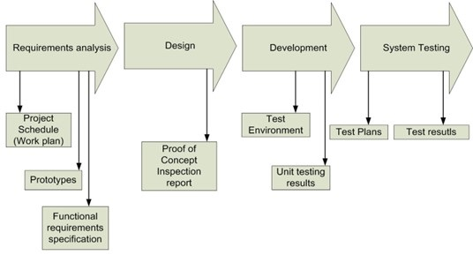

Figure 1. Development Lifecycle.

Finaly, it should be noted that in every project step, all deviations from the previous phases must be traced; when this situation arises, the changed impact should be assessed. Impacts can include cost, schedules and risk. The process for managing the change will involve the following steps:

* Assess impact
* Design and agree to a solution
* Estimate the cost of the solution
* Update and re-issue the affected documentation
* Actions related to proposed changes.

### Risk Analysis

Risks refer to events that, when triggered, cause problems. Risk sources may be internal or external to the system that is the target of risk management. For instance: a source can exist in the activities of a given WP and can generate a risk in another WP in which the risk will be managed. In that case, the risk source can be considered as external.

The identification of risks will originate from a “top-down” or “bottom up” approach. In the “top-down” approach, the PI will check the potential risks during each research team meeting; in the “bottom-up” approach, each project member can notify a risk during meetings, which will be evaluated by the PI. Then the risk assessment process follows, with each risk being quantified according to its impact and probability of occurrence, that will lead to the team’s response to it following the steps illustrated in Figure 2.

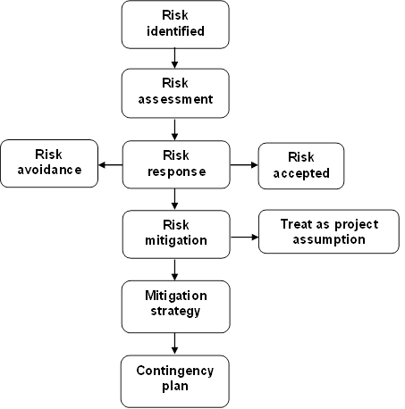

Figure 2. Risk Identification Process.

The identified risk will be added in the project Risk Management Table with corresponding contingency plan, according to the issues identified. The initial table (see Table 2), as foreseen in the Technical Document, is defining clear solutions for the identified risks. This risk table will be updated based at least on semi-annual and annual report timeline.

|  |  |  |
| --- | --- | --- |
| **Description of risk (Likelihood)** | **WP** | **Proposed risk –Mitigation measures** |
| Neuroscientific hypotheses of imagined speech may not be sufficient to guide the design of robust decoding schemes. (Medium) | 2 | Deploy generic EGG decoding schemes that have proven to be efficient in alternative BCI paradigms. |
| Variability of EEG signal between sessions, datasets, environments, etc. (High) | 2 | Explore personalized decoding schemes that can adequately discriminate among the prompts of imagined speech. |
| Realization that the EEG is not capable of capturing the phainomena of interest. (Low) | 2 | Exploit existing collaboration with AUTH, to perform the experiments using the fNIRS device of the institution. Tailor algorithms accordingly. |
| Deep Learning algorithms require more data for precise mental speech decoding. (Medium) | 2 | Suitable data augmentation techniques will be employed. |
| The cues selected for the experimental protocol may elicit unwanted brain patterns that interfere with the ones of imagined speech. (Medium) | 3 | Identify alternative cues for the experimental protocol (e.g. tactile cues) that could limit or terminate the interference. |
| A new COVID outburst limits participant recruitment. (Medium) | 3 | The number of participants will be limited and the iterative process of rehearsal experiments will be confined to the members of our lab. |

Table 2. Risk Table

# Summary

This document presented the methodology that will be employed in BINGO to facilitate the smooth execution of the project. More specifically, we have defined the roles, the responsibilities and duties of every key person in the project. Moreover, we have specified the procedures that will ensure the quality of our results, as well as smooth communication and collaboration among the research team members. Finally, important references have been made to the risk management and financial plan of the project.

## Appendix

## References